**“food choice’’**

**group members**

**Project Instructor**

**Miss Sana Sheeraz**

ABDUR RAFAY KHAN

ABU HURAIRA KHAN

HAFIZ MUHAMMAD HAMZA ALI



SPLASH SCREEN

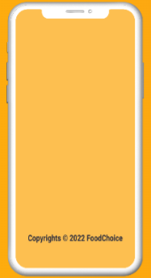

ON BOARD:

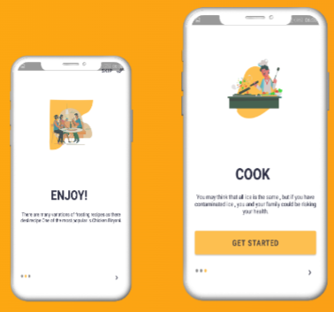

Navigation Drawer:

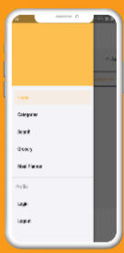

User Dashboard



Login/SignUp StartUp Screen:

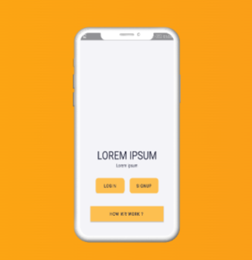

**Problem Statement**

**Food Choice App**

The main aim of developing this Android-based mobile Carve your Choice Food App is to provide easy food application to the users those who want to explore tasty food in their kitchen. This app can be helpful to the newcomers to prepare delicious food.

**EXISTING SOLUTION**

* Displays only recipe description by selecting the particular recipe
* only shows grocery items
* individual details of each ingredient

**PROBLEM**

* Many people want to do a variety of recipes in their homes.
* Some people may have a habit of preparing a variety of cuisines in their homes and they try to browse and cook.
* Here there is a problem arises of ingredients, some may be available may not be available and it takes more time to search and can’t find nutrition facts directly.

**DISADVANTAGES OF EXISTING SOLUTION**

* Manually typing about the items
* Doesn’t show each and every detail of vegetables
* It requires more time to search for recipes.

**PROPOSED SYSTEM**

We are going to provide a Carve your Choice Food App for different ingredients like organic food and inorganic food materials with their use cases and also we are linking up with videos so that everyone can access easily

**ADVANTAGES OF PROPOSED SYSTEM**

* Time-saving, Conduit-free setup, and maintenance
* Ease of Use and Implementation
* It is useful for bachelors
* The people who don’t know cooking
* It can show the diet details so that we can follow healthy tips

**MODULES**

***User (My Recipes):***

Users can add and edit the recipes of their choice.

***Grocery list:***

Users can select any type of ingredients according to the categories existing in the database and can prepare their cuisines.

***Cook Recipes:***

The user can find many varieties of recipes and can choose their favorite ones to prepare.

***Meal Planner:***

According to the person, they can plan their diet for the whole day that is breakfast, lunch, and dinner.

***Kitchen tips and tricks:***

People can follow some of the tips that they need for their kitchens.

**CONCLUSION**

As our food-related idea is useful for a number of people we are providing features for literate and illiterate people so that the person can easily understand and they can prepare any type of recipe using this app and can learn the easy way of cooking with their available items.

**Work Behind on Project**

1. 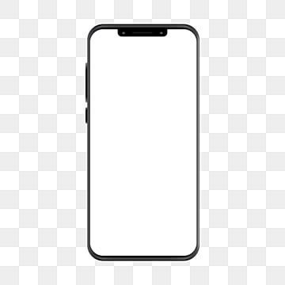Some Screens design left
2. Database Operation left

